**Types of Legal Entities:**

1. **Sole Trader**:
   * One individual runs the business.
   * The individual is liable for all business debts (personal assets like home, savings at risk).
2. **Partnership**:
   * Two or more people share responsibility.
   * Joint and several liability (all partners are fully liable for the debts).
   * Often used by professionals (e.g., doctors, lawyers).
3. **Limited Liability Partnership (LLP)**:
   * Partners have limited liability.
   * A legal entity separate from its owners.
4. **Limited Company**:
   * A separate legal person from its owners.
   * Divided into shares, limiting the owners' liability to the amount they’ve invested.
   * **Private Ltd (Ltd)**: Shares not offered to the public.
   * **Public Ltd (PLC)**: Shares offered to the public.

**Why a Limited Company is Preferred:**

* Limited liability for owners (they only risk what they’ve invested).
* Easier to raise capital by selling shares.
* It exists separately from the owners.

**Key Terms:**

* **Takeover**: When one company buys another by acquiring its shares.
* **Merger**: Two companies join to form a new one.
* **Management Buyout**: When a company’s management buys out the existing owners.
* **Outsourcing**: Contracting out certain tasks (e.g., IT services) to specialist companies.

**Regulation of Limited Companies:**

* Must register with Companies House.
* Submit annual reports and accounts.
* Directors must act in good faith, be aware of the company’s financial position, and avoid conflicts of interest.

**Other Bodies:**

1. **Non-Commercial Bodies**:
   * Government-run organizations (e.g., NHS, police, schools).
   * Aim to provide public services, not make profits.
2. **Charities/Non-Profit**:
   * Legal status as a company limited by guarantee.
   * Profits are not distributed to members but used for charitable purposes.

**Setting up a Company:**

* Registering costs around £100 (UK).
* Memorandum and Articles of Association are the key documents.
* No lawyer or accountant needed—many use "off-the-shelf" companies.

**Directors’ Responsibilities:**

* Act in good faith for the company's benefit.
* Declare conflicts of interest.
* Submit annual reports and accounts.

**Takeovers & Mergers:**

* Takeover: Larger company buys a smaller one (e.g., cash, shares, or both).
* Merger: Two companies combine to create a new entity.

**Management Buyouts & Outsourcing:**

* **Buyout**: Management buys out the owners.
* **Outsourcing**: Hiring external firms for specialized tasks like IT.

**Annual Report​ (finance and accounting):**

* Required for public companies.
* Provides information to shareholders about operations and financial conditions.
* Includes:
  + General corporate information.
  + Financial highlights.
  + Financial statements (balance sheet, income statement, cash flow statement).
  + Auditor's report.
  + Summary of financial data.

**2. Balance Sheet:**

* Shows what the company **owns** (assets) and **owes** (liabilities) at a specific point.
* **Net Worth**: The difference between assets and liabilities, showing the company’s financial value.
* **Depreciation**: Gradual reduction in the value of fixed assets over time.

**3. Assets:**

* **Fixed Assets**: Long-term assets (e.g., land, machinery) used to generate income.
* **Current Assets**: Short-term assets (e.g., cash, inventory) that can be easily converted to cash.
* Example: Cars for business use are fixed assets, while cars for resale by a dealer are current assets.

**4. Depreciation:**

* **Straight Line Method**: Depreciate an asset's cost evenly over its useful life.
* Example: A server bought for Rs. 100,000 depreciated by Rs. 20,000 each year for 5 years.

**5. Working Capital​:**

* Calculated as **current assets minus current liabilities**.
* Represents the money available for day-to-day operations.

**6. Creditors:**

* **Current liabilities**: Debts due within one year.
* **Long-term liabilities**: Debts due after more than a year.

**7. Profit and Loss Account​:**

* Shows how much money has been received and spent over a period.
* Does not include money borrowed or spent on fixed assets.

**8. Cash Flow​:**

* Ties together the balance sheet, profit and loss account, and capital expenditure.
* Represents cash available after covering short-term obligations.

**Why Capital is Needed:**

* **Capital**: Wealth in money or assets to start a company or invest.
* **Reasons for needing capital**:
  + Customers may delay payments after services.
  + Business needs funds for purchasing supplies, equipment, and living expenses.
  + Cash required for salaries, rent, marketing, equipment, and other operational costs.
  + If developing a product/package, more money and time are needed upfront.

**2. Business Plan:**

* A plan is necessary to convince funders the business is feasible.
* The business plan should include:
  + A description of the business and market, showing expertise and technical feasibility.
  + Market analysis, competition assessment, and target audience.
  + Financial forecasts: budgets, cash flow predictions, balance sheets, and profit/loss projections.

**3. Sources of Finance - Grants:**

* **Grants**:
  + Used for capital investment (e.g., premises, equipment).
  + Usually come with conditions and require additional funding from other sources.
  + Grants are often a **short-term solution** and cover part of the investment.

**4. Sources of Finance - Loans:**

* **Loans**:
  + If the company liquidates, the lender recovers the loan from asset sales.
  + **Overdraft loans**: Short-term borrowing; can be withdrawn by the bank.
  + **Long-term loans**: Fixed period and rate; repayment of capital at the end of the term.
  + **Soft loans**: Lower interest rates, typically for start-ups.
* **Corporate Bonds**:
  + Debt instruments issued by companies to raise capital.
  + Pay fixed interest regularly (fixed-income securities).

**5. Sources of Finance – Equity Capital:**

* **Equity Capital**:
  + Money invested in exchange for company shares.
  + **Business angels** and **venture capitalists** invest to grow the company and sell shares at a profit.
  + Shares are taken from the difference between issued and authorized capital.

**6. Gearing or Leverage:**

* **Gearing**: Relationship between loan capital and equity capital.
  + **High gearing** is undesirable because:
    - Too much is committed to loan payments, leaving little for shareholders.
    - Lenders may worry that high debt encourages risky trading behavior.

**1. Bureaucratic Model:**

* **Structure**: Hierarchical, tasks are specialized.
* **Advantages**: Clear authority, efficient, merit-based hiring, and predictability.
* **Disadvantages**: Can lead to boredom, low productivity, and inefficiency.

**2. Organic Model:**

* **Characteristics**: Flexible, less rigid, cross-functional teams, free-flowing information.
* **Advantages**: Adaptable to changes, decentralized decision-making, emphasis on expertise over authority.

**3. Matrix Management:**

* **Structure**: Employees work on multiple projects and report to different managers.
* **Advantages**: Combines skills, fosters collaboration, innovation, and flexibility.
* **Disadvantages**: Potential conflicts, dual reporting.

**4. Structuring Principles:**

* **By Function**: Based on departments like operations, marketing, and R&D.
* **By Geography**: Used by multinational companies, accounting for cultural and linguistic differences.
* **By Product Line**: Common in industries like motor vehicles and software, focuses on specific product types.
* **By Market Sector**: Organizes by the type of customer market (e.g., IT industry).
* **By Technology**: Divides teams based on technological expertise (e.g., AI, web systems).
* **Operational Structure**: Often project-based (e.g., custom software, motor vehicle manufacturing).

**5. Centralization vs. Decentralization:**

* **Centralized**: Power concentrated at the top.
* **Decentralized**: Power distributed, common in tech companies.

**6. Job Design:**

* **Project-Based**: Jobs aligned with project plans.
* **Bureaucratic**: Narrow, defined roles leading to high turnover.
* **Solutions**:
  + **Job rotation**: Moving employees through different tasks.
  + **Job enlargement**: Expanding roles to include more tasks.
  + **Job enrichment**: Making jobs more fulfilling.

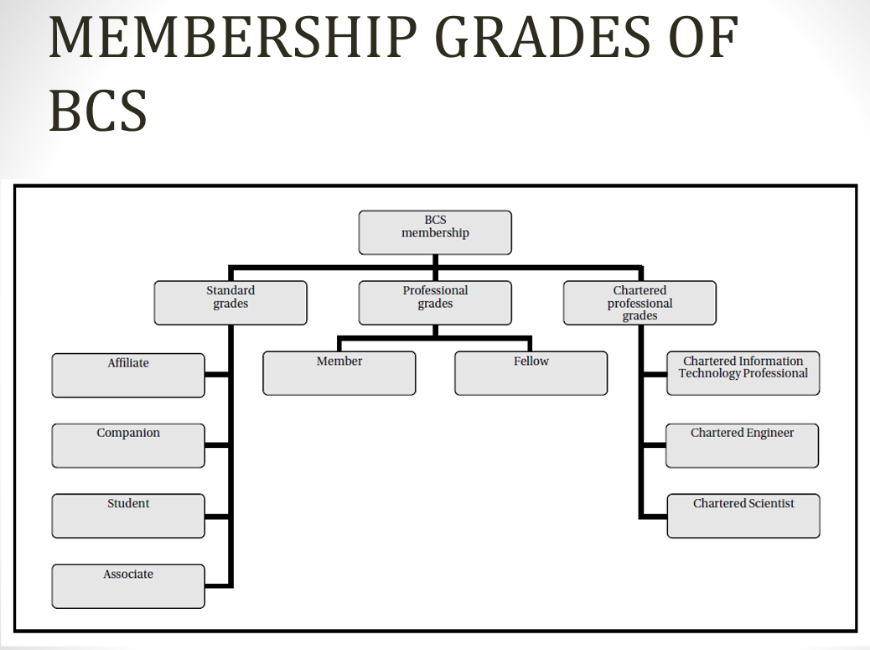

**Nature of a Profession:**

* **Professional**: Prioritizes the organization’s interests over personal convenience and performs tasks competently and conscientiously.
* Common characteristics of a profession:
  + Requires substantial education and training.
  + The profession controls entry through standards.
  + It is organized into professional bodies with codes of conduct and disciplinary procedures.

**2. Professional Bodies:**

* **Functions**:
  + Establish codes of conduct.
  + Disseminate knowledge through publications and conferences.
  + Set education and experience standards for membership.
  + Advise governments and regulatory bodies.
* **Royal Charter**: Grants legitimacy to a professional body (e.g., BCS in 1984).

**3. Reservation of Title and Function:**

* **Reservation of Title**: Legal monopoly where a title like "architect" is reserved for those registered with a specific body (e.g., Architects Act 1997).
* **Reservation of Function**: Certain activities (e.g., auditing) are restricted by law to members of specific professional bodies (e.g., Chartered Accountants).

**4. The Status of Engineers:**

* **USA**:
  + Engineers must be registered with the State Engineers Registration Board to use the title "engineer".
  + Engineering work must be supervised by a registered engineer.

**5. Arguments for Licensing Software Engineers:**

* **For**:
  + Prevents disasters like Therac-25 (USA) and London Ambulance System failures.
  + Ensures professionalism and safety in critical systems.
* **Against**:
  + Challenges in defining critical vs. non-critical systems.
  + Diversity of roles in software engineering.
  + Rapid technological advancements that licensing cannot keep up with.
  + The global nature of software development complicates standardization.

**6. Software Engineers Registration Difficulties:**

* **Diversity**: Software engineers specialize in various fields (e.g., system architecture, UI design).
* **Rapid Change**: Technologies evolve quickly, making licensing hard to maintain.
* **Self-Regulation**: The software industry relies on certifications from bodies like IEEE and ACM.
* **Global Collaboration**: Software development is global, making standardized licensing difficult.

**7. Continuing Professional Development (CPD):**

* **BCS Support**: BCS offers resources for members to keep skills up to date (e.g., publications, courses).
* **Industry Standards**: Models like SFIAplus help organizations ensure their training meets industry best practices.

**8. Advancement of Knowledge:**

* Professional bodies like IEEE and ACM provide journals and organize conferences to advance industry knowledge.